

Programme Name: ________**BCS HONS**_______________________________________

Course Code: __**CSC 2624**________

Course Name: _______**Distributed And Parallel Computing**____________________________

**Internal Examination**

Date of Submission: ______**8/26/2021**_____________

**Submitted By: Submitted To:**

Student Name**: Dipesh Tha Shrestha** Faculty Name**: Manoj Gautam**

IUKL ID: **041902900028** Department**: LMS**

Semester**: Fourth Semester**

Intake**: September 2019**

1. **Write a java program with a two class Server.java and Client.java to implement a network programming. Server must listen on the port 8000 and should be able to accept client request and send back the original data to the client.**

**Answer:**

As we know, we need 2 folders (client and server) to run the above program. In given folder it will have its own files which will help them to connect with each other. Therefore, Code to to accept client request and send back the original data to the client is given below:

**Server.java**

import java.io.BufferedReader;

import java.io.DataOutputStream;

import java.io.IOException;

import java.io.InputStreamReader;

import java.net.ServerSocket;

import java.net.Socket;

public class Server {

public static *void* main(String[] *args*) throws IOException { *String* clientSentence;

*String* capitalizedSentence;

*ServerSocket* welcomeSocket = new ServerSocket(8000); System.out.println("Server is

listening at port: " + 8000); while (true) {

*Socket* connectionSocket = welcomeSocket.accept();

*BufferedReader* fromClient = new BufferedReader(new InputStreamReader(connecti

onSocket.getInputStream()));

clientSentence = fromClient.readLine(); capitalizedSentence =

clientSentence.toUpperCase() + "\n";

*DataOutputStream* toClient = new DataOutputStream(connectionSocket.getOutput

Stream());

toClient.writeBytes(capitalizedSentence);

}

}

}

**Client.java**

import java.io.*;

import java.net.*;

public class Client {

public static *void* main(String[] *args*) throws Exception { try {

String sentence;

String modifiedSentence;

BufferedReader inFromUser = new BufferedReader(new InputStreamReader(System.

in));

Socket clientSocket = new Socket("127.0.0.1", 8000);

DataOutputStream outToServer = new DataOutputStream(clientSocket.getOutputSt

ream());

sentence = inFromUser.readLine(); outToServer.writeBytes(sentence + "\n");

InputStreamReader ins = new InputStreamReader(clientSocket.getInputStream());

BufferedReader inFromServer = new BufferedReader(ins);

modifiedSentence = inFromServer.readLine();

System.out.println("The data received from the server is " + modifiedSentence);

outToServer.flush();

outToServer.close(); clientSocket.close();

} catch (Exception e) { System.out.println(e);

}

}

}

1. **Write a JAVA RMI Server and Client program to calculate Power of a number such that Rmiregistry listen on port 9200**.

**Answer:**

As we know, we need 2 folders (client and server) to run the above program. In given folder it will have its own files which will help them to connect with each other. Folder client will have 3 files named as Client.java, Number.java and RemoteCalcObject.java whereas Folder server will have Server.java, Number.java and NumberImpl.java. Therefore, Code for above program is given below:

**Folder Server**

**Server.java**

import java.rmi.server.UnicastRemoteObject;

import java.rmi.registry.LocateRegistry;

import java.rmi.registry.Registry;

public class Server {

    public static *void* main(String[] *args*) {

        try {

            NumberImpl n1 = new NumberImpl(4);

            Number stub1 = (Number) UnicastRemoteObject.exportObject(n1, 0);

            Registry registry = LocateRegistry.getRegistry("127.0.0.1", 9300);

            registry.bind("number", stub1);

        } catch (Exception e) {

            System.out.println("Error :" + e);

        }

    }

}

**Number.java**

import java.rmi.*;

public interface Number extends Remote {

    public *double* getNum() throws RemoteException;

}

**NumberImpl.java**

import java.rmi.*;

import java.rmi.server.*;

public class NumberImpl implements Number{

*double* numm;

    NumberImpl(*double* *newnumm*) throws RemoteException{

        this.numm = *newnumm*;

    }

    public *double* getNum() throws RemoteException{

        return this.numm;

    }

}

**Folder Client**

**Client.java**

import java.rmi.*;

import java.rmi.registry.*;

public class Client {

    public static *void* main(*String*[] *args*) throws *RemoteException*, *NotBoundException* {

     try {

*Registry* remoteRegistry = LocateRegistry.getRegistry("127.0.0.1", 9200);

*Number* numm = (Number) remoteRegistry.lookup("number");

*RemoteCalcObject* remoteCalcObject = new RemoteCalcObject();

*double* finalnum = remoteCalcObject.computerPower(numm.getNum());

 System.out.println("The power of " + numm.getNum() + " by 2 is " + finalnum);

        } catch (*Exception* *e*) {

            System.out.println("Clinet error occoured " + e.toString());

        }

    }

}

**Number.java**

import java.rmi.*;

public interface Number extends Remote {

    public *double* getNum() throws RemoteException;

}

**RemoteCalcObject.java**

import java.lang.Math;

class RemoteCalcObject {

    RemoteCalcObject() {

    }

    public *double* computerPower(*double* *num*) {

        return Math.pow(*num*, 2);

    }

}

**Output:**

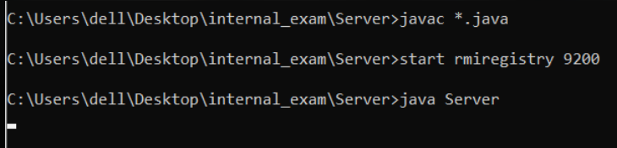

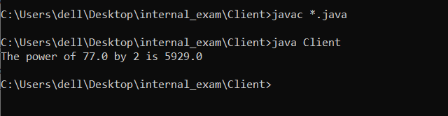

**Thank You**